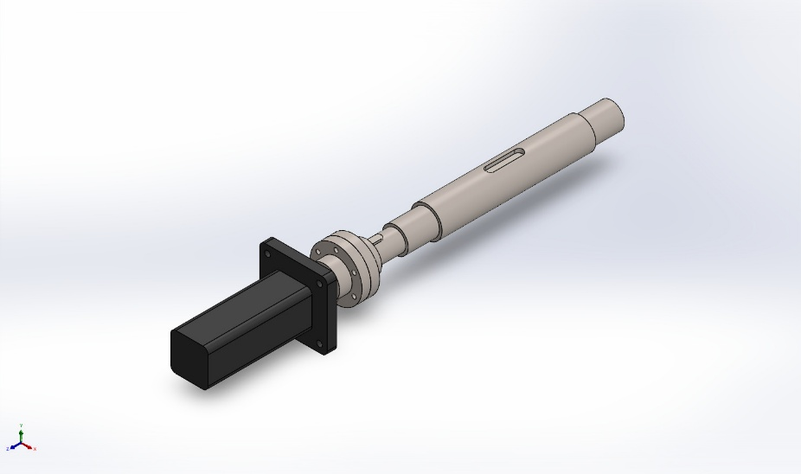 | Simulation of Motor and motor bracket  Date: April 20, 2026  Designer: Solidworks  Study name: Frequency 1  Analysis type: Frequency  Table of Contents  Description 1  Assumptions 2  Model Information 3  Study Properties 5  Units 6  Material Properties 6  Loads and Fixtures 7  Connector Definitions 8  Interaction Information 8  Mesh information 9  Sensor Details 10  Study Results 11  Conclusion 32

Description
No Data

Assumptions

Model Information

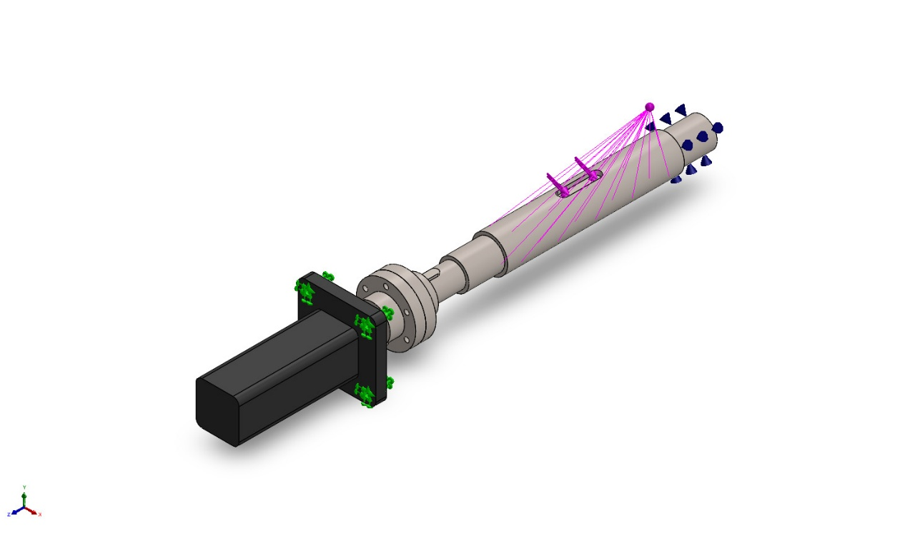
Model name: Motor and motor bracket
Current Configuration: Default
Solid Bodies
Document Name and Reference | Treated As | Volumetric Properties | Document Path/Date Modified
Imported1  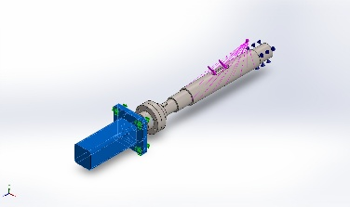 | Solid Body | Mass:1.31215 kg  Volume:0.000182243 m^3  Density:7,200 kg/m^3  Weight:12.8591 N | C:\Users\26869\Desktop\game\Solidwork\resource\model\第44-46、50、53课\Motor and motor bracket\Motor and motor bracket.SLDPRT
Imported2  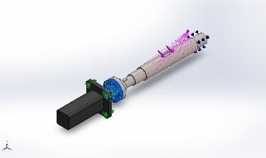 | Solid Body | Mass:0.153275 kg  Volume:1.99058e-05 m^3  Density:7,700 kg/m^3  Weight:1.50209 N | C:\Users\26869\Desktop\game\Solidwork\resource\model\第44-46、50、53课\Motor and motor bracket\Motor and motor bracket.SLDPRT
Imported3  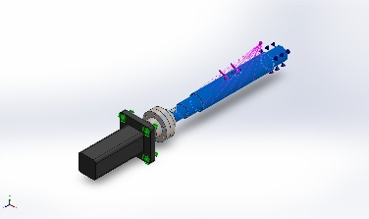 | Solid Body | Mass:1.12653 kg  Volume:0.000146303 m^3  Density:7,700 kg/m^3  Weight:11.04 N | C:\Users\26869\Desktop\game\Solidwork\resource\model\第44-46、50、53课\Motor and motor bracket\Motor and motor bracket.SLDPRT
Imported4  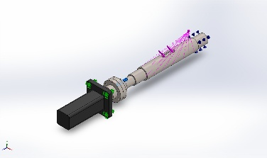 | Solid Body | Mass:0.00617056 kg  Volume:8.01372e-07 m^3  Density:7,700 kg/m^3  Weight:0.0604715 N | C:\Users\26869\Desktop\game\Solidwork\resource\model\第44-46、50、53课\Motor and motor bracket\Motor and motor bracket.SLDPRT
Imported5  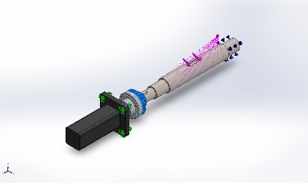 | Solid Body | Mass:0.138284 kg  Volume:1.7959e-05 m^3  Density:7,700 kg/m^3  Weight:1.35519 N | C:\Users\26869\Desktop\game\Solidwork\resource\model\第44-46、50、53课\Motor and motor bracket\Motor and motor bracket.SLDPRT

Study Properties
Study name | Frequency 1
Analysis type | Frequency
Mesh type | Solid Mesh
Number of frequencies | 20
Decouple the mixed free body modes | Off
Solver type | FFEPlus
Soft Spring: | Off
Incompatible bonding options | Automatic
Thermal option | Include temperature loads
Zero strain temperature | 298 Kelvin
Include fluid pressure effects from SOLIDWORKS Flow Simulation | Off
Result folder | SOLIDWORKS document (C:\Users\26869\Desktop\game\Solidwork\resource\model\第44-46、50、53课\Motor and motor bracket)

Units
Unit system: | SI (MKS)
Length/Displacement | mm
Temperature | Kelvin
Angular velocity | Rad/sec
Pressure/Stress | N/m^2

Material Properties
Model Reference | Properties | Components
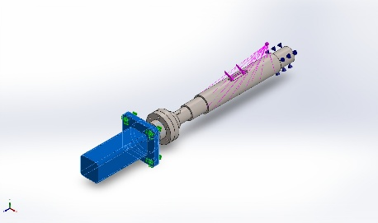 | Name: Gray Cast Iron  Model type: Linear Elastic Isotropic  Default failure criterion: Mohr-Coulomb Stress  Tensile strength: 1.51658e+08 N/m^2  Mass density: 7,200 kg/m^3  Elastic modulus: 6.61781e+10 N/m^2  Poisson's ratio: 0.27  Thermal expansion coefficient: 1.2e-05 /Kelvin | SolidBody 1(Imported1)(电机支架)
Curve Data:N/A
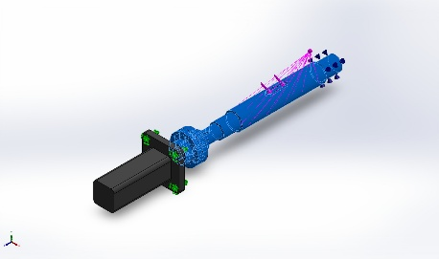 | Name: Alloy Steel  Model type: Linear Elastic Isotropic  Default failure criterion: Max von Mises Stress  Yield strength: 6.20422e+08 N/m^2  Tensile strength: 7.23826e+08 N/m^2  Mass density: 7,700 kg/m^3  Elastic modulus: 2.1e+11 N/m^2  Poisson's ratio: 0.28  Thermal expansion coefficient: 1.3e-05 /Kelvin | SolidBody 2(Imported2)(电机支架),  SolidBody 3(Imported3)(电机支架),  SolidBody 4(Imported4)(电机支架),  SolidBody 5(Imported5)(电机支架)
Curve Data:N/A

Loads and Fixtures
Fixture name | Fixture Image | Fixture Details
Fixed-1 | 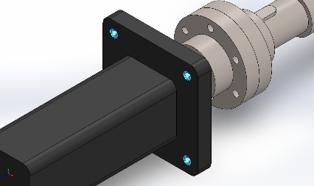 | Entities: 4 face(s)  Type: Fixed Geometry

Load name | Load Image | Load Details
Torque-1 | 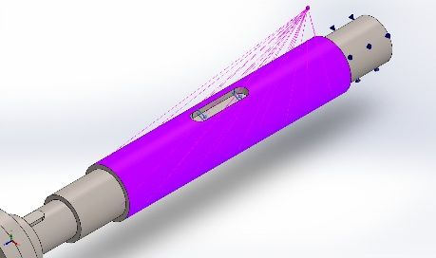 | Entities: 1 face(s)  Reference: Face< 1 >  Type: Apply torque  Value: 100 N.m
Remote Load/Mass (Rigid connection)-1 | 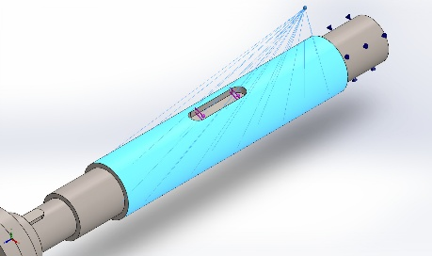 | Entities: 1 face(s)  Type: Load/Mass (Rigid connection)  Coordinate System: Global cartesian coordinates  Force Values: ---, ---, --- N  Moment Values: ---, ---, --- N.m  Reference coordinates: 800 150 50 mm  Remote Mass: 100 kg  Moment of Inertia: 0,0,0,0,0,0 kg.m^2  Components transferred: NA

Connector Definitions

Pin/Bolt/Bearing Connector
Model Reference | Connector Details | Strength Details
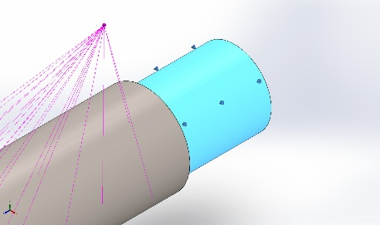  Bearing Support-1 | Entities: 1 face(s)  Type: Bearing | No Data
Connector ForcesNo Data

Interaction Information

Interaction | Interaction Image | Interaction Properties
Component Interaction-3 | 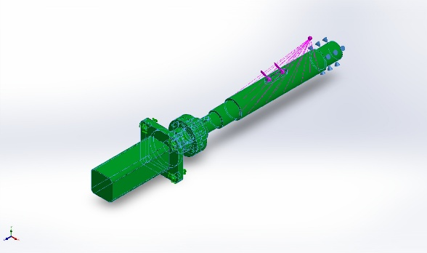 | Type: Bonded  Components: 5 Solid Body (s)  Options: Independent mesh

Mesh information
Mesh type | Solid Mesh
Mesher Used: | Blended curvature-based mesh
Jacobian points for High quality mesh | 16 Points
Maximum element size | 14.3257 mm
Minimum element size | 1.53073 mm
Mesh Quality | High

Mesh information - Details
Total Nodes | 35965
Total Elements | 21287
Maximum Aspect Ratio | 8.4073
% of elements with Aspect Ratio < 3 | 96.2
Percentage of elements with Aspect Ratio > 10 | 0
Percentage of distorted elements | 0
Time to complete mesh(hh;mm;ss): | 00:00:02
Computer name: | REMY

Mesh Quality Plots
Name | Type | Min | Max
Quality1 | Mesh | - | -
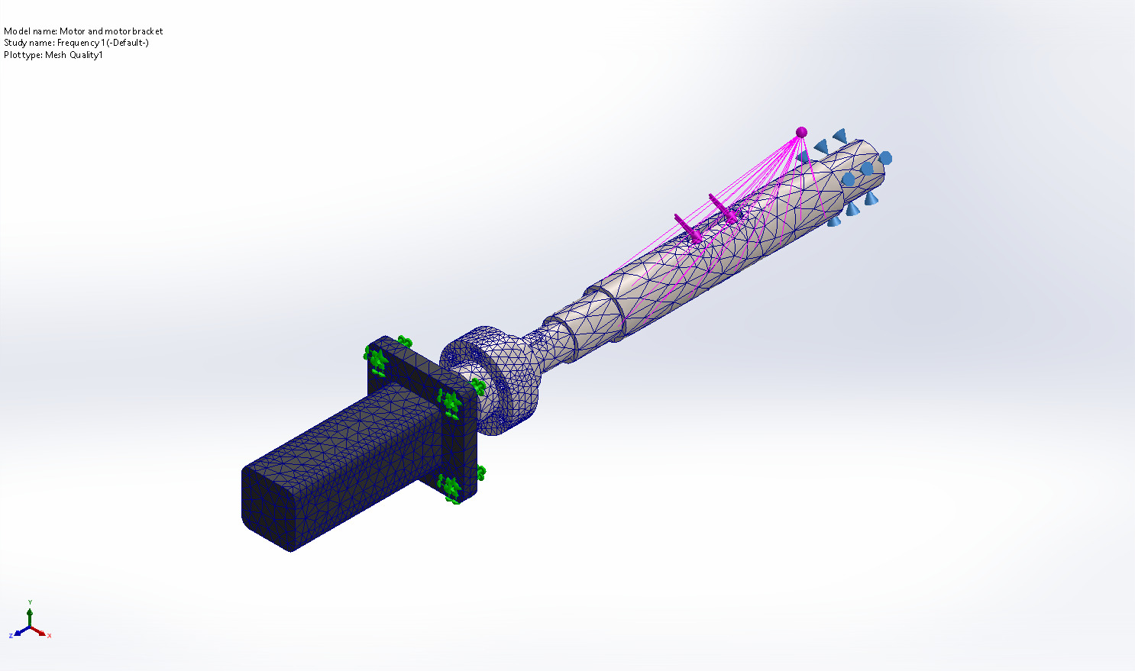
Motor and motor bracket-Frequency 1-Quality-Quality1

Sensor Details
No Data

Study Results

Name | Type | Min | Max
Amplitude1 | AMPRES: Resultant Amplitude Plot for Mode Shape: 1(Value = 7.26854 Hz) | 0.000e+00  Node: 1 | 1.047e-02  Node: 33173
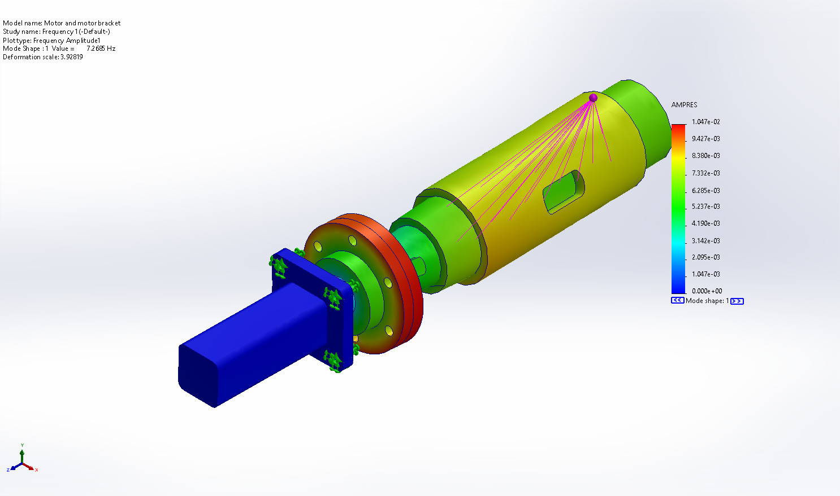
Motor and motor bracket-Frequency 1-Amplitude-Amplitude1

Name | Type | Min | Max
Amplitude2 | AMPRES: Resultant Amplitude Plot for Mode Shape: 2(Value = 48.9592 Hz) | 0.000e+00  Node: 1 | 7.343e-02  Node: 24629
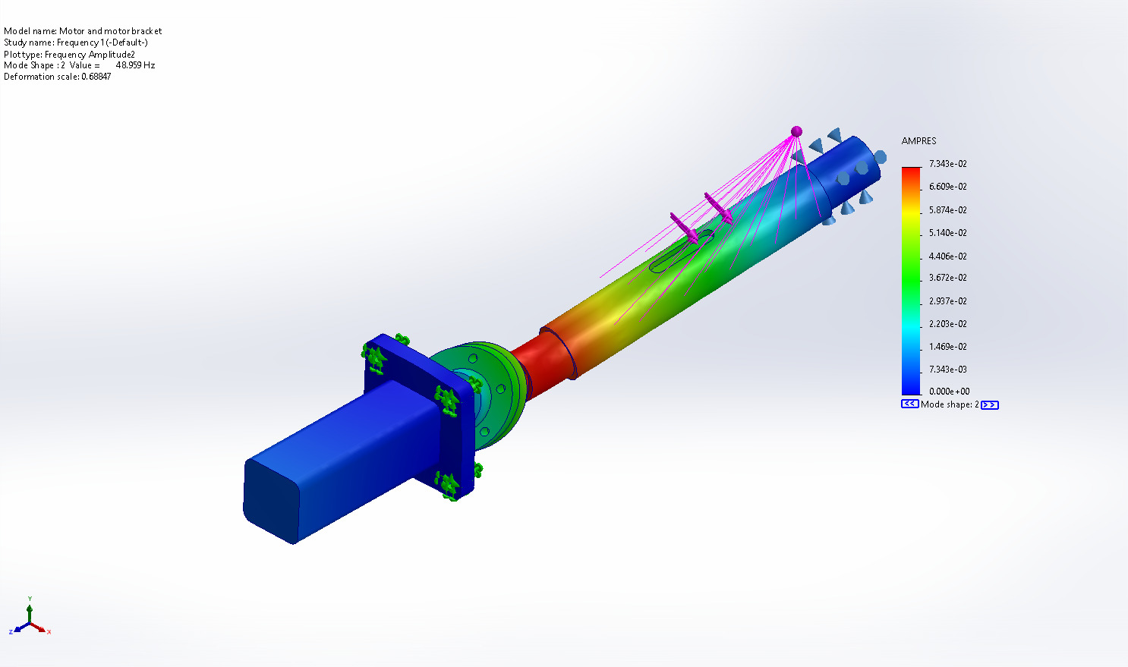
Motor and motor bracket-Frequency 1-Amplitude-Amplitude2

Name | Type | Min | Max
Amplitude3 | AMPRES: Resultant Amplitude Plot for Mode Shape: 3(Value = 889.754 Hz) | 0.000e+00  Node: 1 | 1.362e+00  Node: 26385
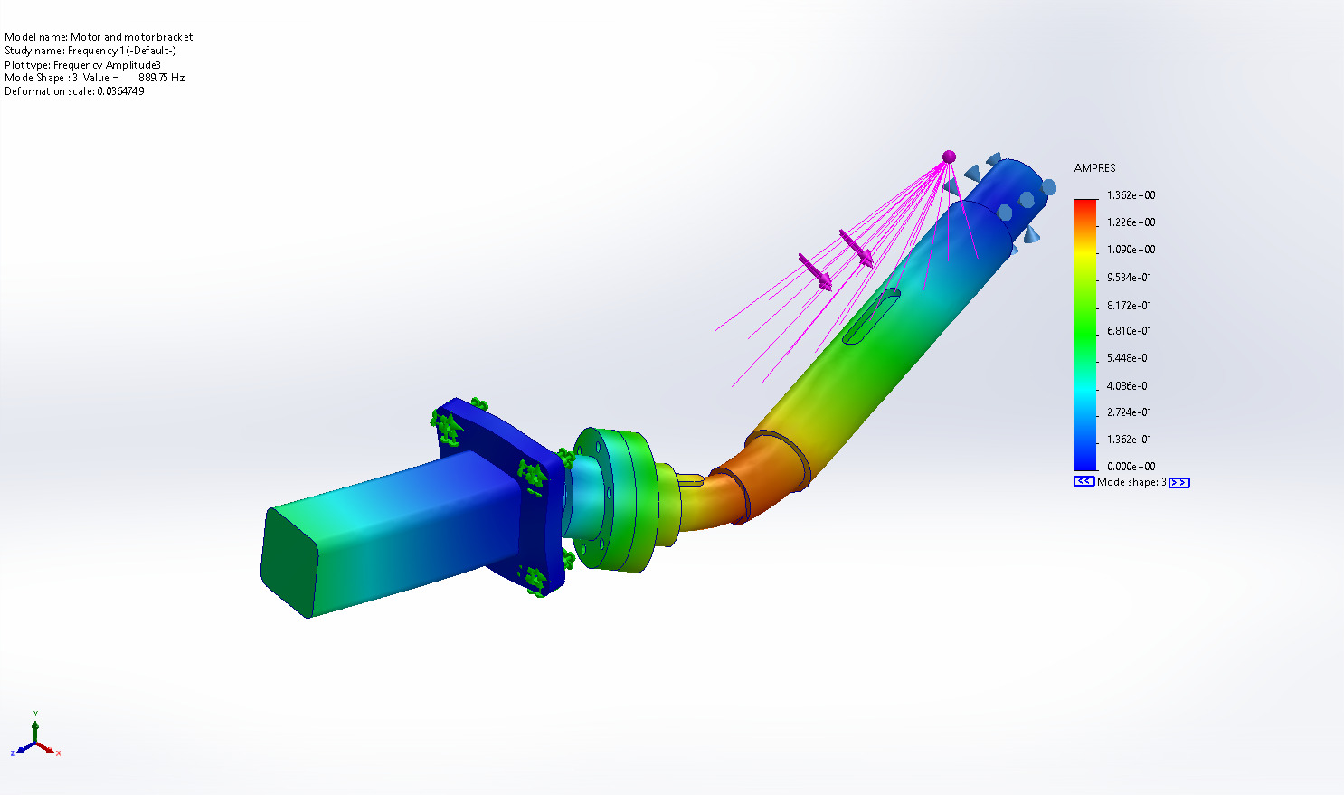
Motor and motor bracket-Frequency 1-Amplitude-Amplitude3

Name | Type | Min | Max
Amplitude4 | AMPRES: Resultant Amplitude Plot for Mode Shape: 4(Value = 1,065.94 Hz) | 0.000e+00  Node: 1 | 1.896e+00  Node: 1138
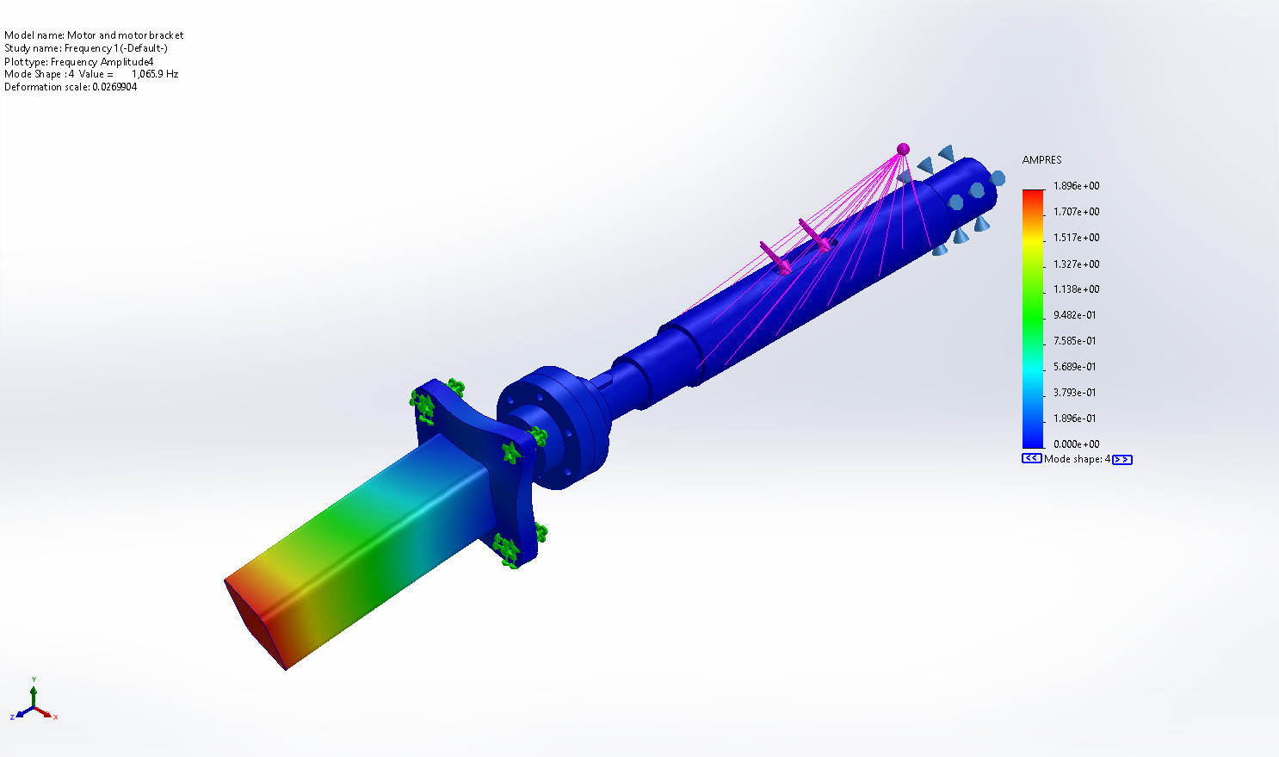
Motor and motor bracket-Frequency 1-Amplitude-Amplitude4

Name | Type | Min | Max
Amplitude5 | AMPRES: Resultant Amplitude Plot for Mode Shape: 5(Value = 1,085.06 Hz) | 0.000e+00  Node: 1 | 1.817e+00  Node: 1135
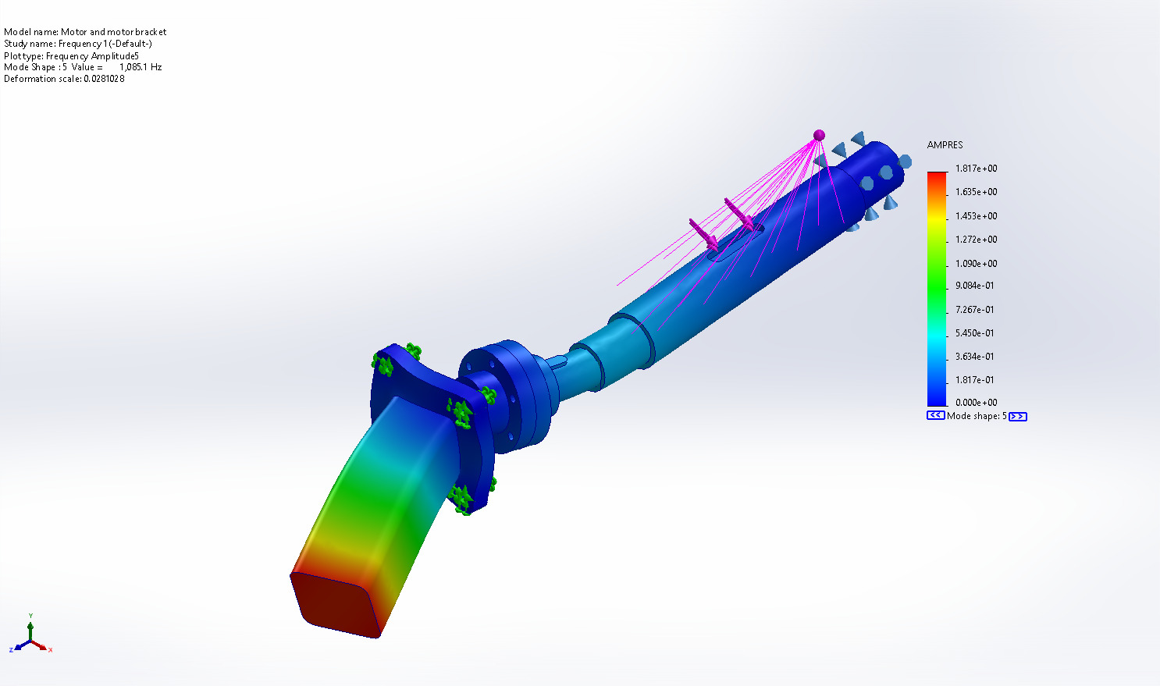
Motor and motor bracket-Frequency 1-Amplitude-Amplitude5

Name | Type | Min | Max
Amplitude6 | AMPRES: Resultant Amplitude Plot for Mode Shape: 6(Value = 1,099.75 Hz) | 0.000e+00  Node: 1 | 1.504e-01  Node: 12928
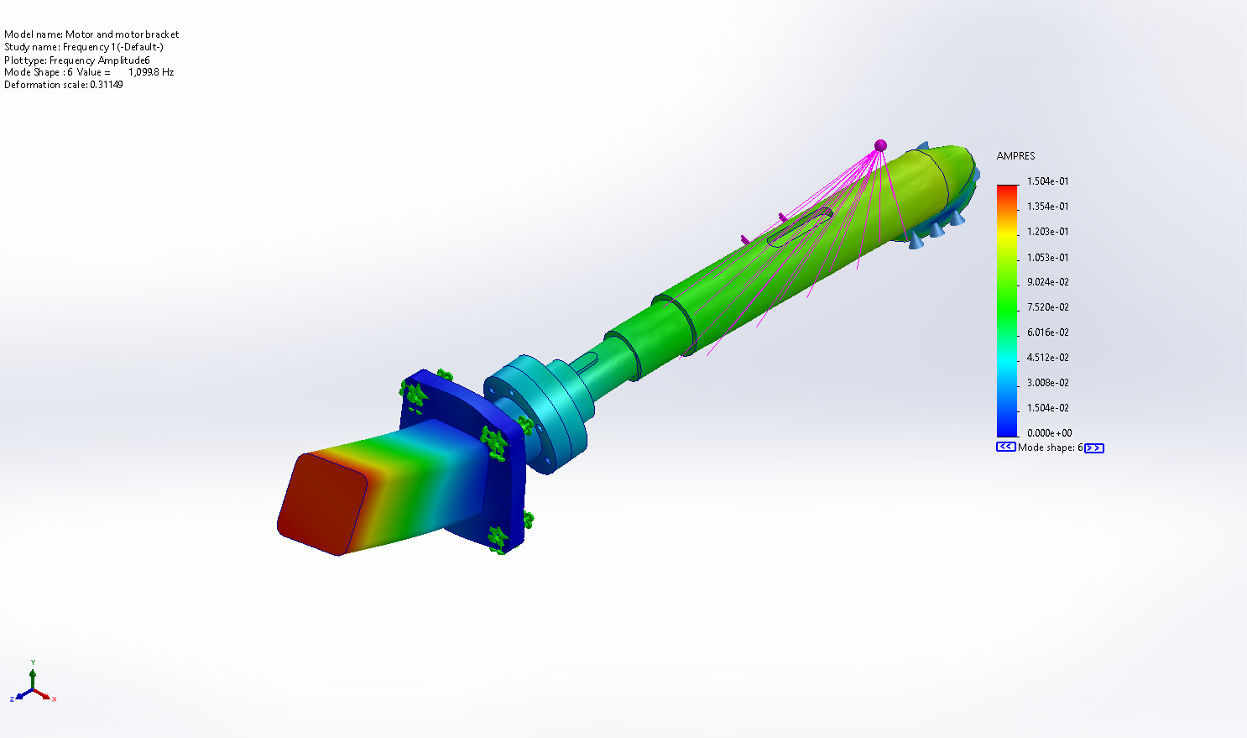
Motor and motor bracket-Frequency 1-Amplitude-Amplitude6

Name | Type | Min | Max
Amplitude7 | AMPRES: Resultant Amplitude Plot for Mode Shape: 7(Value = 3,254.49 Hz) | 0.000e+00  Node: 1 | 2.704e+00  Node: 27638
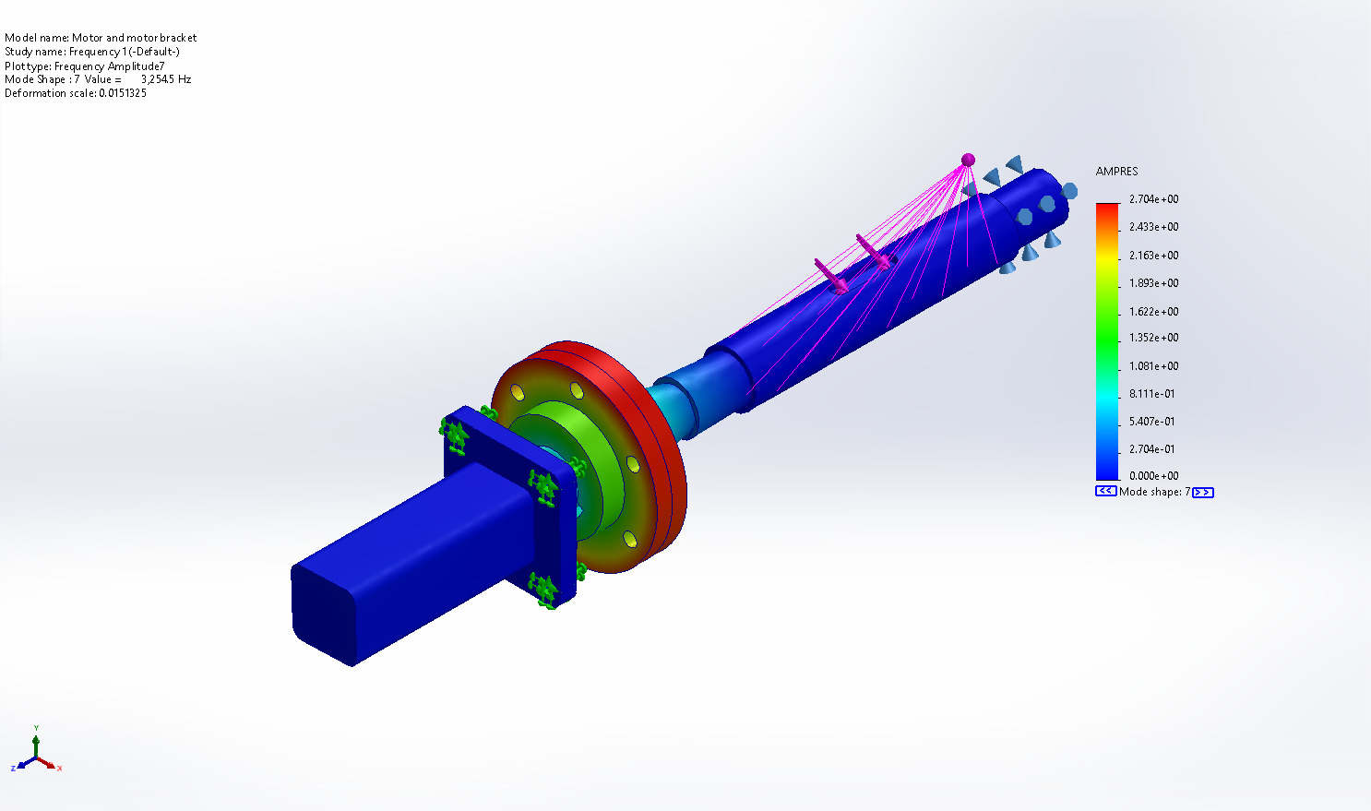
Motor and motor bracket-Frequency 1-Amplitude-Amplitude7

Name | Type | Min | Max
Amplitude8 | AMPRES: Resultant Amplitude Plot for Mode Shape: 8(Value = 3,661.3 Hz) | 0.000e+00  Node: 1 | 1.656e+00  Node: 27669
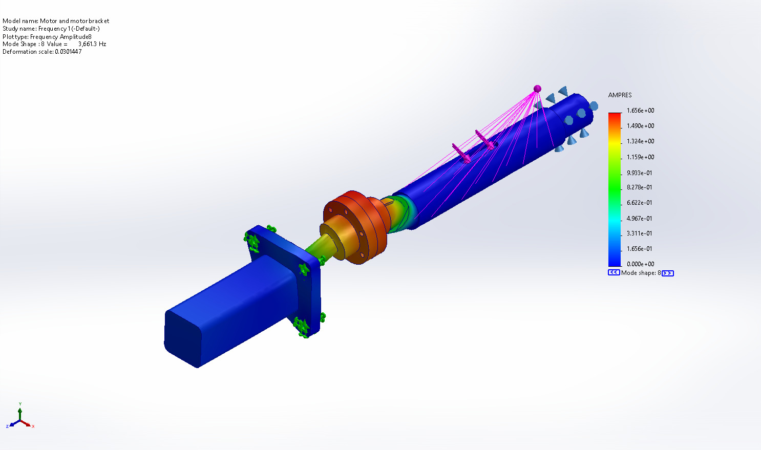
Motor and motor bracket-Frequency 1-Amplitude-Amplitude8

Name | Type | Min | Max
Amplitude9 | AMPRES: Resultant Amplitude Plot for Mode Shape: 9(Value = 4,026.22 Hz) | 0.000e+00  Node: 1 | 1.067e+00  Node: 1155
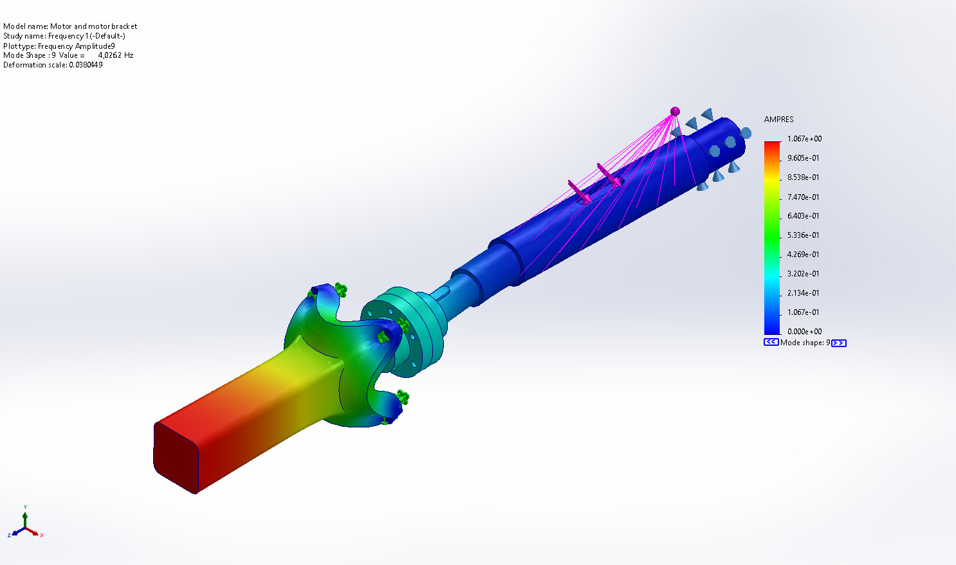
Motor and motor bracket-Frequency 1-Amplitude-Amplitude9

Name | Type | Min | Max
Amplitude10 | AMPRES: Resultant Amplitude Plot for Mode Shape: 10(Value = 4,141.98 Hz) | 0.000e+00  Node: 1 | 2.295e+00  Node: 1135
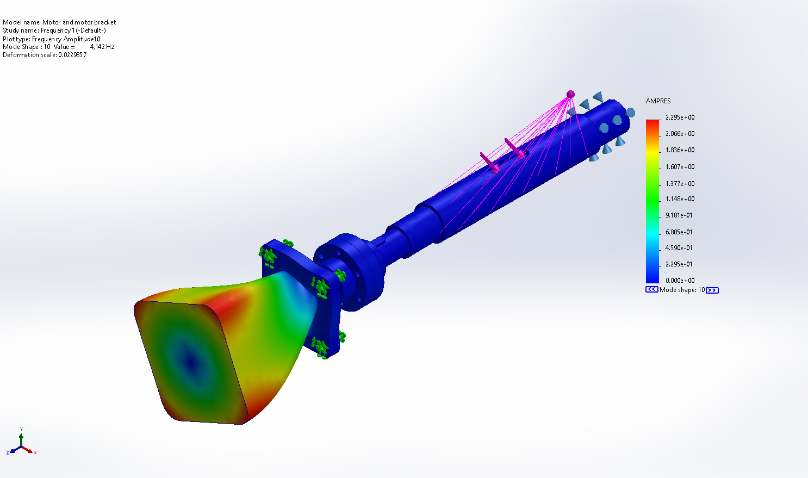
Motor and motor bracket-Frequency 1-Amplitude-Amplitude10

Name | Type | Min | Max
Amplitude11 | AMPRES: Resultant Amplitude Plot for Mode Shape: 11(Value = 4,271.61 Hz) | 0.000e+00  Node: 1 | 1.661e+00  Node: 13688
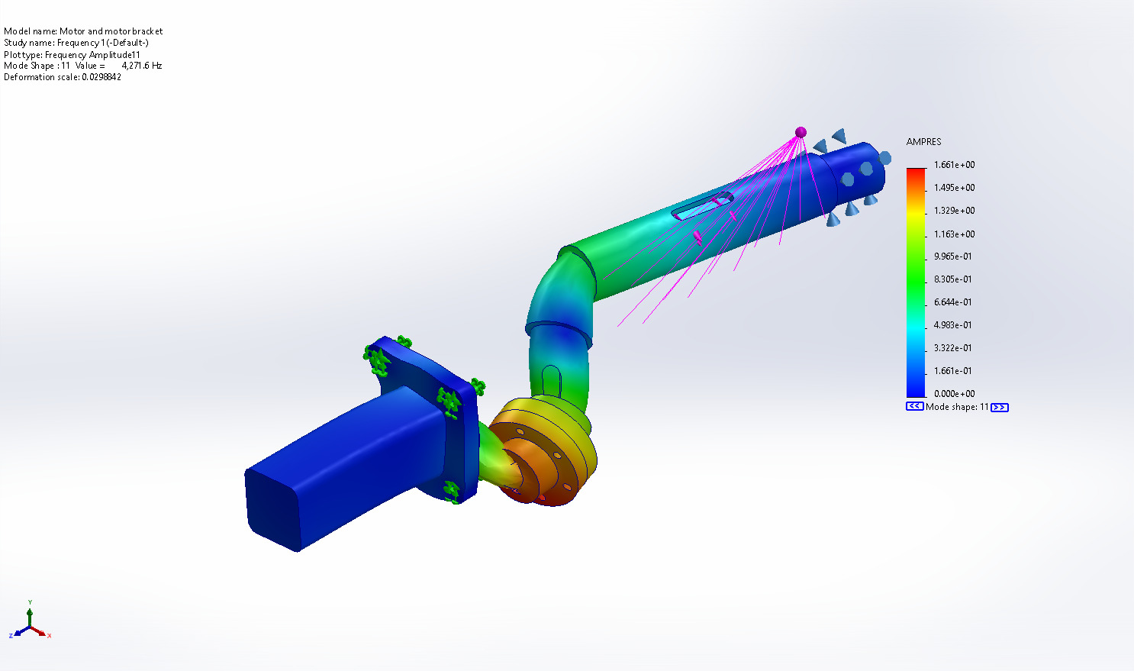
Motor and motor bracket-Frequency 1-Amplitude-Amplitude11

Name | Type | Min | Max
Amplitude12 | AMPRES: Resultant Amplitude Plot for Mode Shape: 12(Value = 5,656.66 Hz) | 0.000e+00  Node: 1 | 2.007e+00  Node: 13324
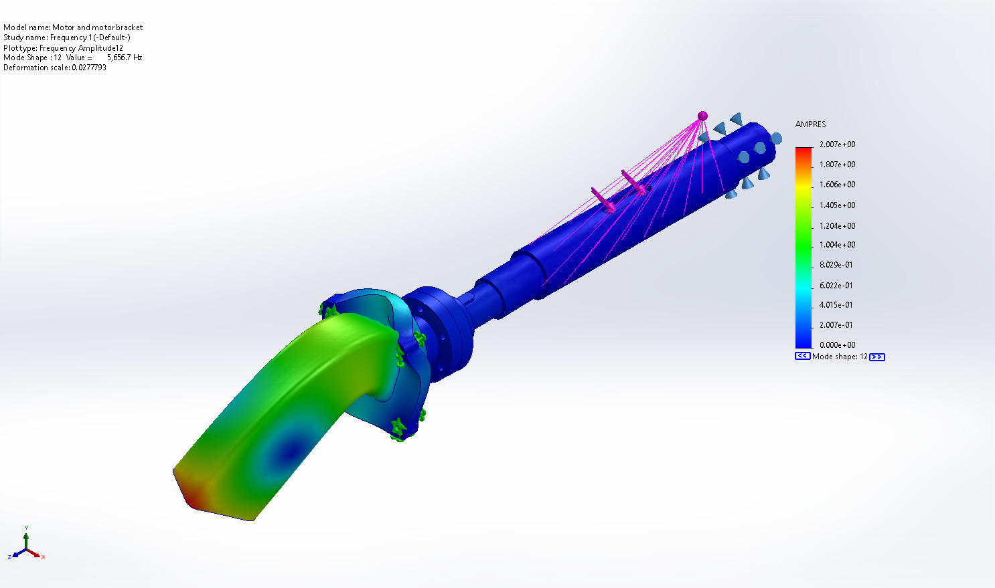
Motor and motor bracket-Frequency 1-Amplitude-Amplitude12

Name | Type | Min | Max
Amplitude13 | AMPRES: Resultant Amplitude Plot for Mode Shape: 13(Value = 5,660.2 Hz) | 0.000e+00  Node: 1 | 2.011e+00  Node: 4212
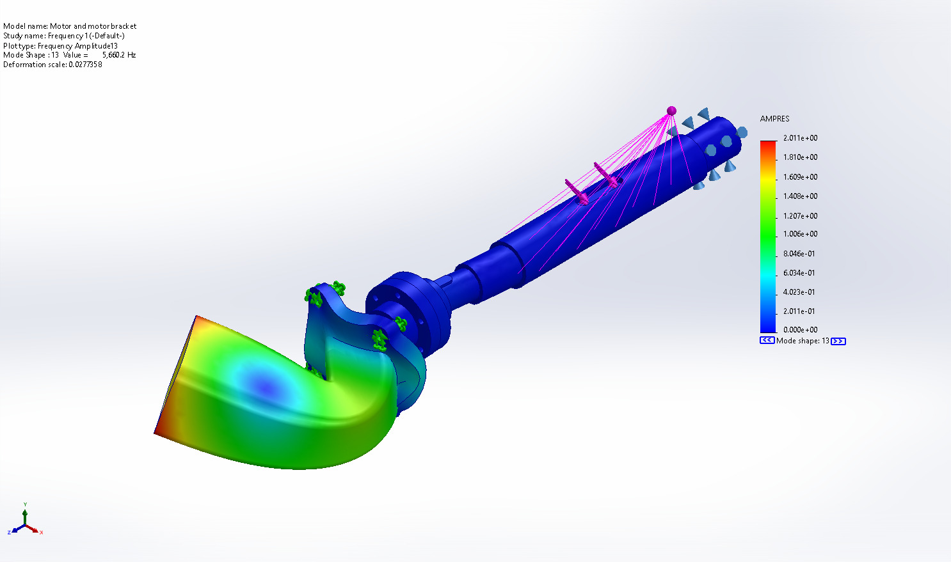
Motor and motor bracket-Frequency 1-Amplitude-Amplitude13

Name | Type | Min | Max
Amplitude14 | AMPRES: Resultant Amplitude Plot for Mode Shape: 14(Value = 8,071.02 Hz) | 0.000e+00  Node: 1 | 2.472e+00  Node: 13687
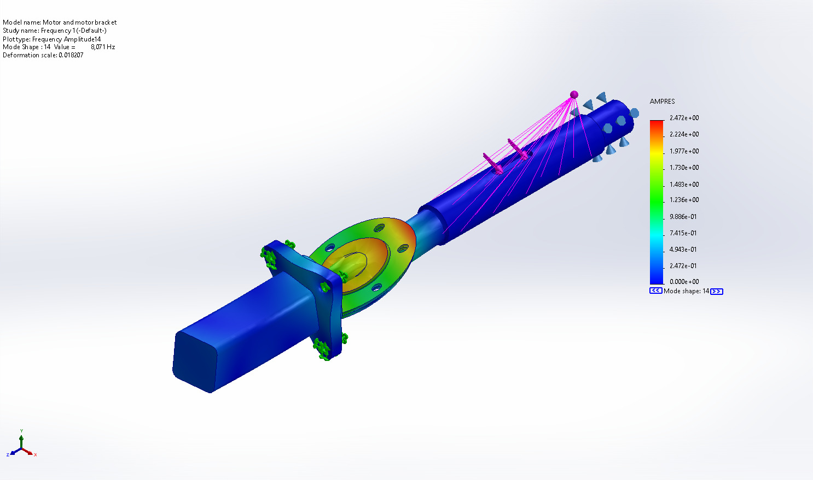
Motor and motor bracket-Frequency 1-Amplitude-Amplitude14

Name | Type | Min | Max
Amplitude15 | AMPRES: Resultant Amplitude Plot for Mode Shape: 15(Value = 8,574.94 Hz) | 0.000e+00  Node: 1 | 2.418e+00  Node: 13697
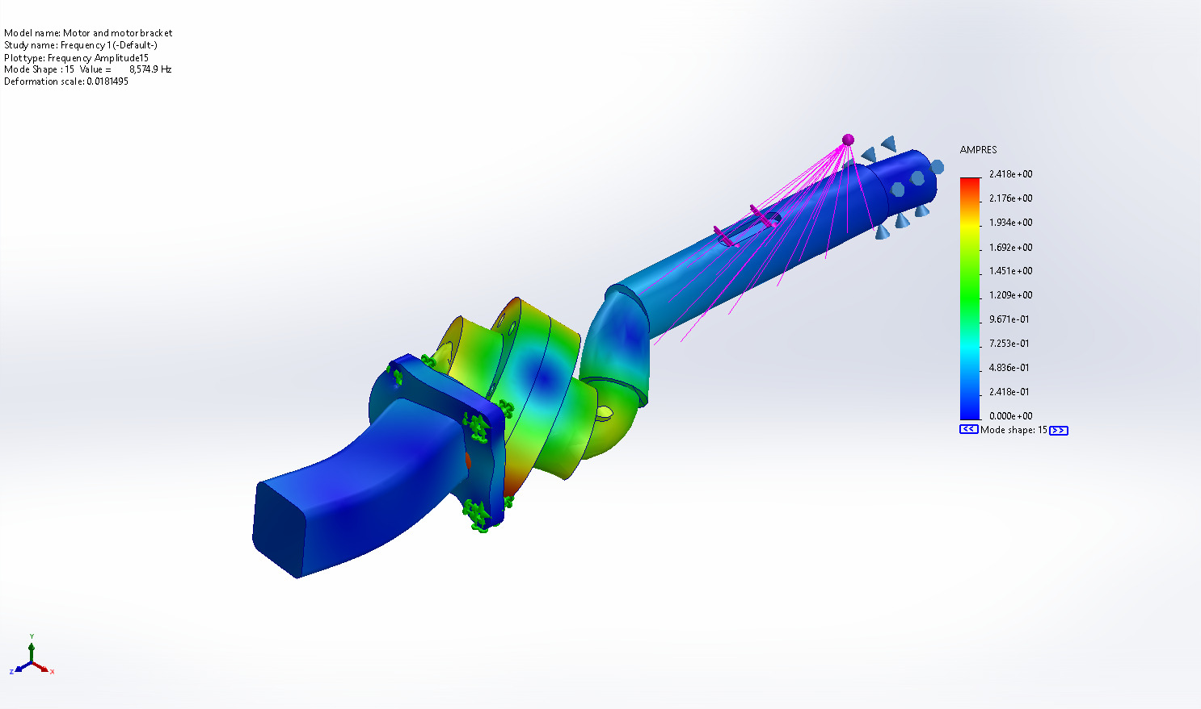
Motor and motor bracket-Frequency 1-Amplitude-Amplitude15

Name | Type | Min | Max
Amplitude16 | AMPRES: Resultant Amplitude Plot for Mode Shape: 16(Value = 9,546.42 Hz) | 0.000e+00  Node: 1 | 1.616e+00  Node: 27669
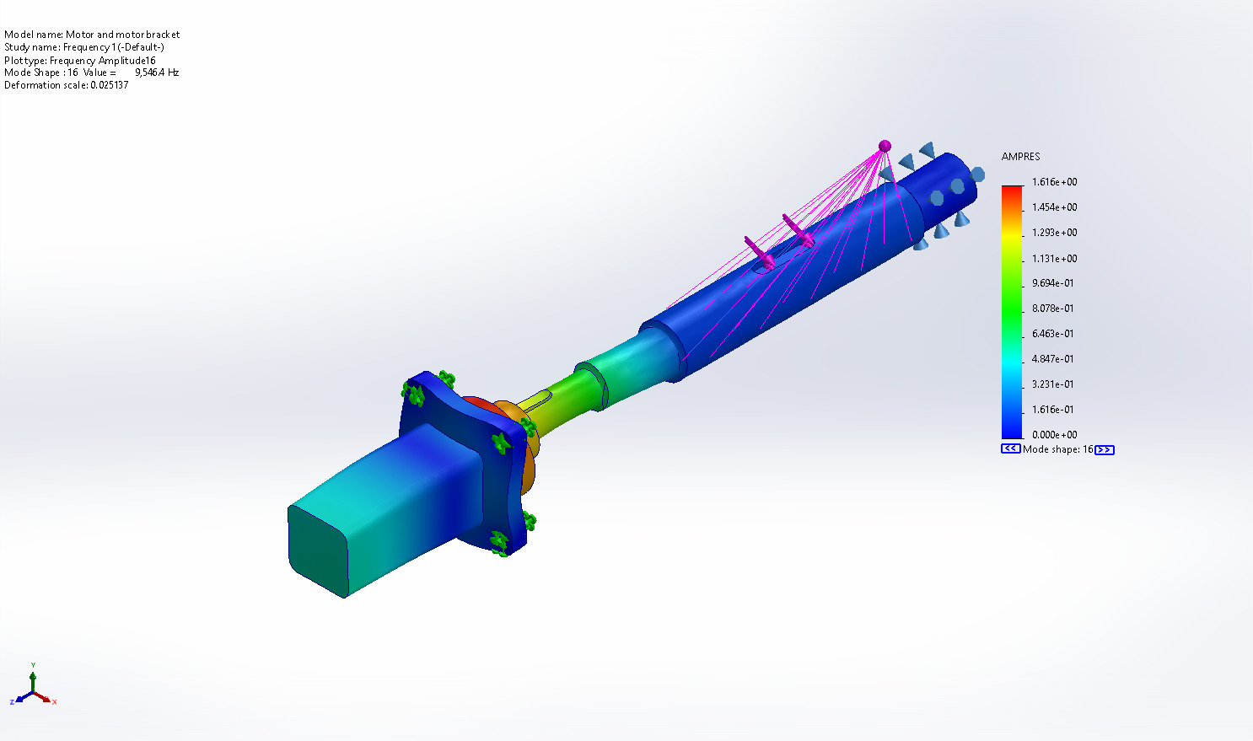
Motor and motor bracket-Frequency 1-Amplitude-Amplitude16

Name | Type | Min | Max
Amplitude17 | AMPRES: Resultant Amplitude Plot for Mode Shape: 17(Value = 11,763.6 Hz) | 0.000e+00  Node: 1 | 1.703e+00  Node: 13324
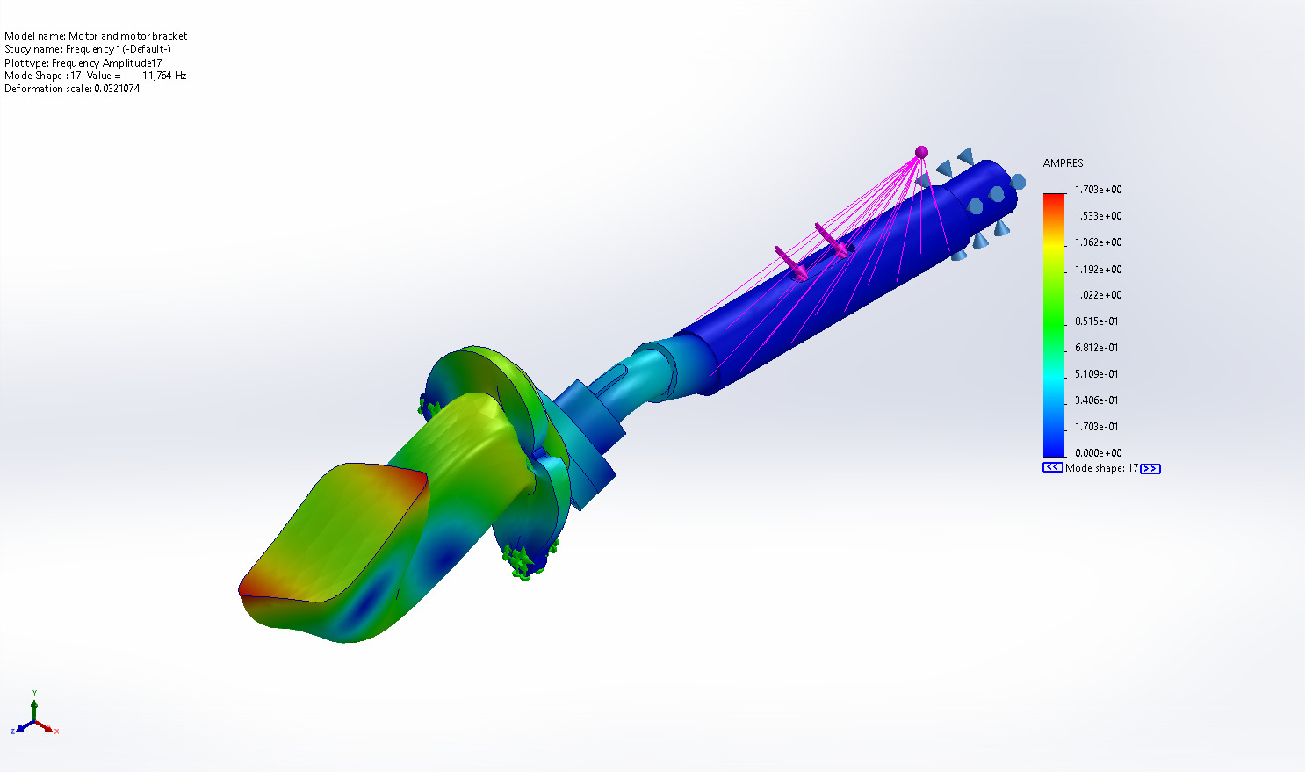
Motor and motor bracket-Frequency 1-Amplitude-Amplitude17

Name | Type | Min | Max
Amplitude18 | AMPRES: Resultant Amplitude Plot for Mode Shape: 18(Value = 11,805 Hz) | 0.000e+00  Node: 1 | 1.717e+00  Node: 12933
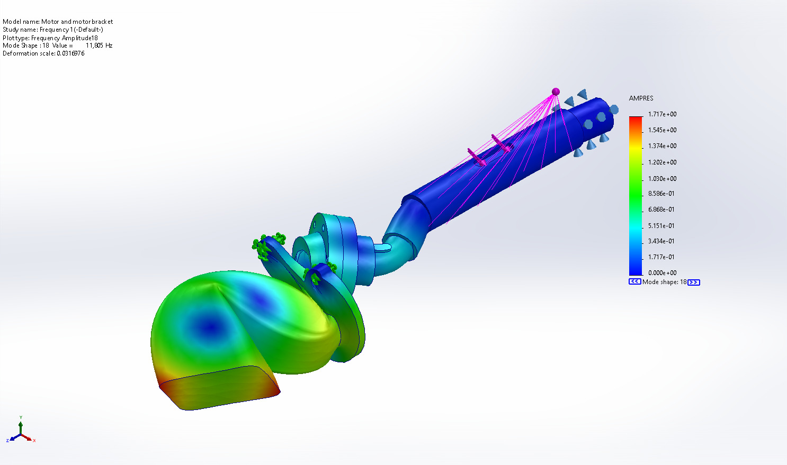
Motor and motor bracket-Frequency 1-Amplitude-Amplitude18

Name | Type | Min | Max
Amplitude19 | AMPRES: Resultant Amplitude Plot for Mode Shape: 19(Value = 12,273.1 Hz) | 0.000e+00  Node: 1 | 2.324e+00  Node: 1136
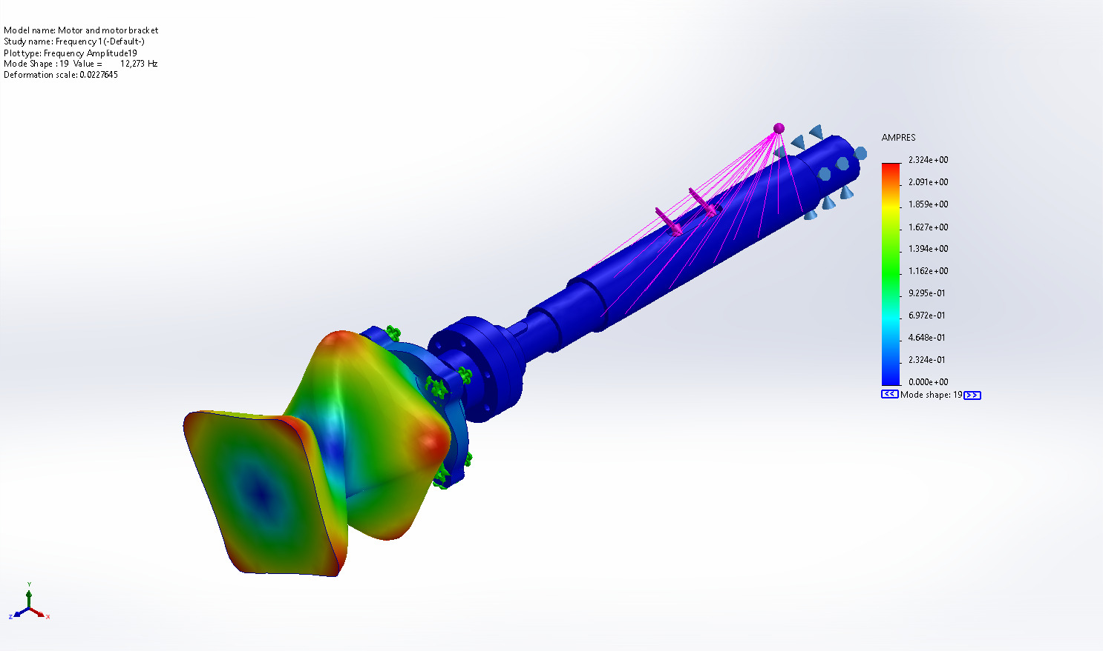
Motor and motor bracket-Frequency 1-Amplitude-Amplitude19

Name | Type | Min | Max
Amplitude20 | AMPRES: Resultant Amplitude Plot for Mode Shape: 20(Value = 13,738.2 Hz) | 0.000e+00  Node: 1 | 2.463e+00  Node: 387
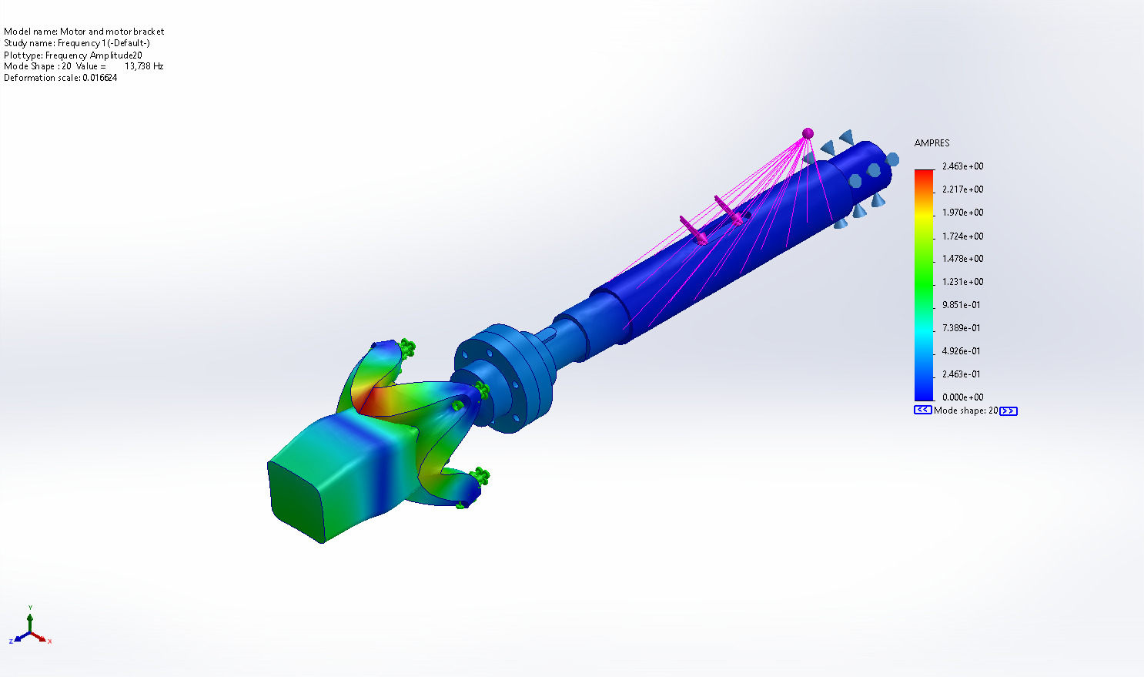
Motor and motor bracket-Frequency 1-Amplitude-Amplitude20

Mode List
Frequency Number | Rad/sec | Hertz | Seconds
1 | 45.67 | 7.2685 | 0.13758
2 | 307.62 | 48.959 | 0.020425
3 | 5,590.5 | 889.75 | 0.0011239
4 | 6,697.5 | 1,065.9 | 0.00093813
5 | 6,817.7 | 1,085.1 | 0.0009216
6 | 6,910 | 1,099.8 | 0.00090929
7 | 20,449 | 3,254.5 | 0.00030727
8 | 23,005 | 3,661.3 | 0.00027313
9 | 25,297 | 4,026.2 | 0.00024837
10 | 26,025 | 4,142 | 0.00024143
11 | 26,839 | 4,271.6 | 0.0002341
12 | 35,542 | 5,656.7 | 0.00017678
13 | 35,564 | 5,660.2 | 0.00017667
14 | 50,712 | 8,071 | 0.0001239
15 | 53,878 | 8,574.9 | 0.00011662
16 | 59,982 | 9,546.4 | 0.00010475
17 | 73,913 | 11,764 | 8.5008e-05
18 | 74,173 | 11,805 | 8.471e-05
19 | 77,114 | 12,273 | 8.1479e-05
20 | 86,319 | 13,738 | 7.279e-05

Mass Participation (Normalized)
Mode Number | Frequency(Hertz) | X direction | Y direction | Z direction
1 | 7.2685 | 0.63251 | 0.34093 | 4.9595e-07
2 | 48.959 | 0.12397 | 0.22902 | 0.62369
3 | 889.75 | 0.0036376 | 0.0019698 | 1.5308e-07
4 | 1,065.9 | 9.1009e-05 | 0.00027915 | 0.0024568
5 | 1,085.1 | 0.0086581 | 0.0027536 | 6.7695e-05
6 | 1,099.8 | 0.22157 | 0.41558 | 0.34986
7 | 3,254.5 | 1.7082e-06 | 3.6417e-06 | 5.3421e-09
8 | 3,661.3 | 0.00058552 | 0.0011456 | 7.7598e-06
9 | 4,026.2 | 6.6651e-06 | 3.8136e-05 | 0.013104
10 | 4,142 | 4.424e-07 | 3.3102e-07 | 4.7594e-07
11 | 4,271.6 | 0.00042747 | 0.00021154 | 5.2937e-05
12 | 5,656.7 | 0.00037742 | 0.002227 | 6.8451e-07
13 | 5,660.2 | 0.0022168 | 0.00037106 | 2.1129e-08
14 | 8,071 | 0.00033926 | 0.00046074 | 1.6963e-05
15 | 8,574.9 | 0.00096779 | 0.00054999 | 7.9264e-06
16 | 9,546.4 | 1.1757e-05 | 6.4358e-05 | 0.0029937
17 | 11,764 | 0.00024238 | 0.0012741 | 1.0658e-06
18 | 11,805 | 0.0010954 | 0.00016788 | 1.2438e-08
19 | 12,273 | 1.4751e-06 | 8.1876e-08 | 2.9155e-11
20 | 13,738 | 2.9137e-06 | 1.6748e-05 | 1.9731e-06
 |  | Sum X = 0.99671 | Sum Y = 0.99707 | Sum Z = 0.99226

Conclusion

